Name: ________________________________ _____/20

3AB Human Biological Science
Reaction Time Investigation

A reflex action should not be confused with reaction time, because reacting to a stimulus involves processing of auditory or visual stimuli in the brain. A reflex action is ‘processed’ in the spinal cord. Of course stimuli are not truly ‘processed’ at a conscious level, but rather at an automatic and involuntary level.

A reaction time to a stimulus can vary between people, especially under certain conditions (intoxication, fatigue, stress etc).

You are to conduct an experiment into the influence of elevated heart-rate due to physical activity, and its affect on reaction time.

Reaction time will be measured according to how quickly a participant can catch a falling ruler. The distance the ruler falls before being caught will be used to calculate the time it took the participant to react and catch it.

The experiment will be conducted in two parts, 10 times each. Condition A will be completed whilst the participant is calm. Condition B will be completed after heart-rate has been accelerated. To accelerate the heart, participants must vigorously run on the spot for 1½ minutes before beginning the experiment.

Participants must be sitting with their forearm flat on the desk. The ruler must hover in line with the participant’s thumb, then released. Distance dropped will be measured inline with the top of the thumb.

Paired participants will swap roles and repeat the experiment. Data will be collated and distributed for discussion and analysis
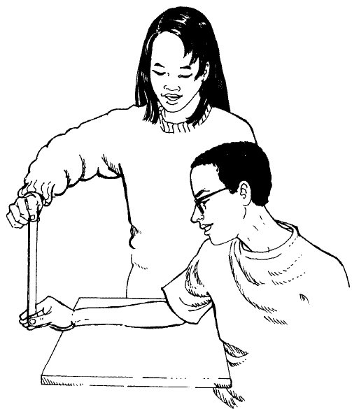
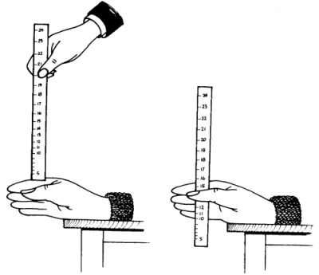

Reaction time will be calculated using the formula below:

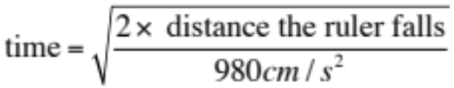 (use 3 decimal places)
Table 1.

Data collected from reaction time experiment.

Trial | Condition A – Calm  (distance) | Reaction time - A  (use equation to calculate) | Condition B – Elevated heart-rate (distance) | Reaction time - B  (use equation to calculate)
1
2
3
4
5
6
7
8
9
10

Name: _____________________________________

Reaction Time Assessment

1. Write a hypothesis for this experiment.

(1 mark)

2. Do you think your hypothesis was supported with the data collected? Why/Why not?

(1 mark)

3. This experiment was conducted in pairs, with each member taking turns at being the experimenter and the participant. Why was an equation used to calculate the reaction time of the participant? (i.e. why didn’t the experimenter use a stopwatch to time the participant’s reaction time?)

The reaction time of the timer (1) will affect the validity (1) of the results
(2 marks)

4. Identify THREE extraneous (uncontrolled) variables, or any other sources of error in this experiment.

(3 marks)

5. Has the data been affected by the “practise effect”? Plot your data on the grid below to find out. (Hint. Trial number is on the horizontal axis)
(4 marks)

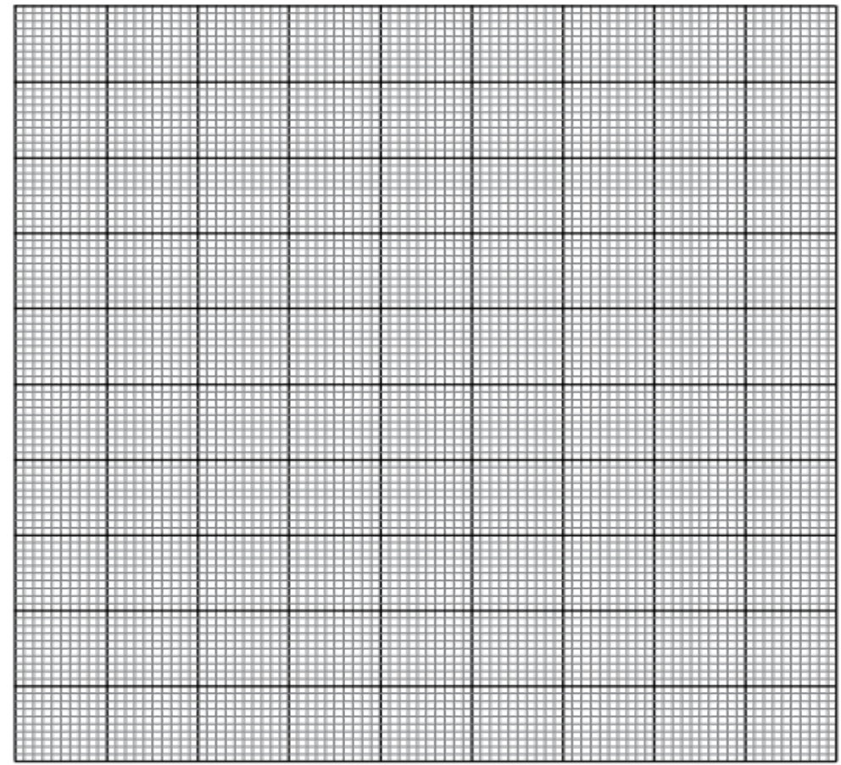

6. Often in research, data can be averaged for comparison and to find the ‘central tendency’ (a number that represents the rest of the data). It would be possible to average the data for Condition A (calm) and the Condition B (elevated heart-rate). Do you think the data collected in this experiment over the 10 trials should be averaged in his case? Why/Why not?

No (1) – because with more trials each person improved (the practise effect) (1) – more focussed, prepared
(2 marks)
7. Draw a flow chart of events that result in the ruler being caught. Include the relevant parts of the brain and spinal cord, and the neurons involved. DO NOT go into detail about action potentials or neurotransmitters. The starting point has been provided for you.
(7 marks)

Visual stimulus of the ruler falling reaches the eyes

Sensory neurons detect stimulus (1)

Sent impulse to cerebral cortex

Cerebral cortex processes impulse (1)

Impulse sent down spinal cord (1) to peripheral NS (1)

Motor neurons (1) carry signal to muscles (1) of arm and hand

+ 1 mark each for mentioning: connector neurons
neurotransmitters
action potential
motor cortex of brain
cerebellum (in context of precision and co-ordination)

ANY 7 POINTS (IN ORDER)

